🧠 0. What Machine Learning REALLY is
At its core:
Machine Learning = Learning a function that maps input → output from data
Example:
- Input: student hours studied
- Output: marks
- ML learns:
marks = f(hours)
That function f is your model

⚙️ 1. Types of Machine Learning (You NEED this clarity)
1. Supervised Learning (MOST IMPORTANT)
You have:
- Inputs (X)
- Outputs (y)
Goal: learn mapping
Problems:
- Regression → predict numbers
(price, speed, temperature)
- Classification → predict categories
(spam/not spam, fraud/not fraud)
👉 This is 80% of what you’ll use initially

2. Unsupervised Learning
No labels, just data.
Goal:
- Find structure
- Group patterns
Example:
- Customer segmentation

3. Reinforcement Learning (for later)
Agent learns via reward/penalty
👉 Important for robotics, drones (your future), but not now

📉 2. The Core ML Pipeline (This is EVERYTHING)
Every ML system you build follows this:
1. Data
Raw → messy
2. Cleaning
- Missing values
- Wrong formats
3. Feature Engineering ⭐
Turn raw data → meaningful inputs
Example:
- date → day, month, weekend
- text → word counts
4. Model
Algorithm learns patterns
5. Training
Adjust parameters
6. Evaluation
Check performance
7. Improvement
Tune, refine
👉 If you master this pipeline, you're already ahead of most beginners.
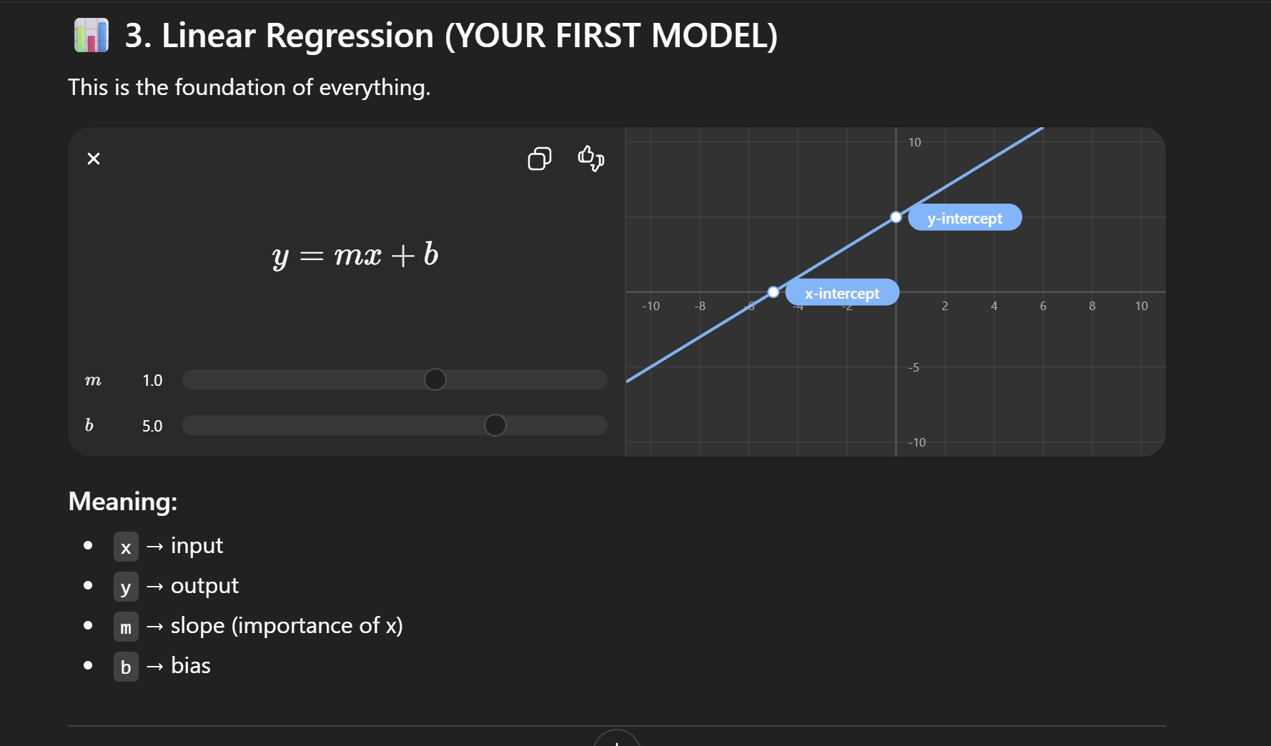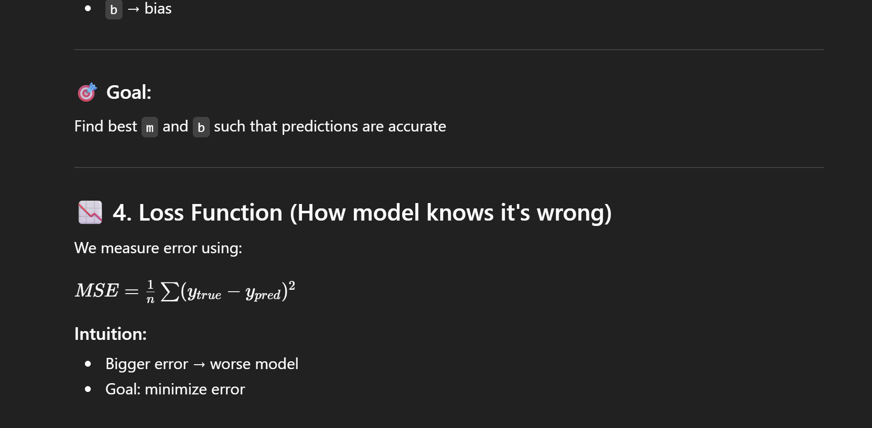
🔄 5. Gradient Descent (HOW model learns)
Core idea:
Adjust parameters step-by-step to reduce error
Think:
- You're blindfolded on a hill
- You take steps downhill
- Eventually reach lowest point
That lowest point = best model

⚠️ 6. Overfitting vs Underfitting
Underfitting
- Model too simple
- Misses patterns
Overfitting
- Model memorizes data
- Fails on new data
👉 Your goal: balance

✂️ 7. Train/Test Split
Why?
Because:
A model that works on training data ≠ good model
Solution:
- Train on 80%
- Test on 20%

📈 8. Classification Models
Logistic Regression
Used for:
- Yes/No
- 0/1
It outputs probability:
P(y = 1 | x)

Metrics you MUST know:
- Accuracy
- Precision
- Recall
- F1 Score
👉 Especially important for interviews

🌲 9. Decision Trees (VERY IMPORTANT)
Think:
A flowchart of decisions
Example:
Is income > 50k?
→ Yes → Buy
→ No → Don't buy

Why powerful?
- Easy to understand
- Works well with real-world messy data

🌳 10. Ensemble Learning (Next Level)
Combine models → better results
Random Forest
- Many trees
- Averaged output
Boosting
- Fix previous mistakes
👉 This is where ML starts becoming industry-level

🧪 11. Feature Engineering (YOUR SECRET WEAPON)
This matters more than models.
Examples:
- Normalize values
- Encode categories
- Create ratios
👉 Good features > fancy models

🔧 12. Model Evaluation & Validation
Cross Validation
Train multiple times on different splits
Why?
- More reliable performance

🧠 13. Bias vs Variance
Concept | Meaning
Bias | Too simple
Variance | Too complex
👉 You balance these
🎯 What THIS gives you
If you truly understand everything above:
You can:
- ✅ Build ML projects
- ✅ Pass beginner interviews
- ✅ Understand tutorials deeply
- ✅ Start applying ML in your startups

🚀 What should click in your brain
You should now see ML as:
Data → Features → Model → Loss → Optimization → Evaluation
Not random libraries.

